00.07
e-signature & Certificates
Process Design & AMOS Configuration Document
Purpose
This Process Design document is provided to Key-Users to record their key decisions regarding the AMOS Process design and the required AMOS configuration.
It is updated throughout the Project Definition Phase and used as the baseline for the Final Acceptance prior to Go-Live
Revision
Author, Name | Date | Notes
ADKE Adam Kelemen | 15.05.2024 | First version

Table of Contents
1. Process Overview & Objectives 2
2. Regulatory References 3
3. Definitions & Glossary 3
4. Process Tasks 4
5. Process Dependencies 4
6. Process Flow 4
7. Process Design Questions 6
8. Data (Source) Mapping 6
9. Other Software Used 7
10. AMOS Configuration 7
a. Basic Data 8
b. Parameters 8
c. Workflows 8
d. Scheduled Tasks 8
e. API’s & Interfaces 9
11. Annex – Additional Info 9

Process Overview & Objectives

Process General Description:
With the help of the eSignature & Certificates process, ACC will have guidance on how to implement and maintain electronic signature (eSign) in AMOS at your company. This is needed if your company wants to implement Paperless Aircraft Maintenance.
The process lists all decisions points and key APN-s which are needed for successful configuration and upkeep.
Main Process Objective (Outputs & Outcomes) :
The main stakeholders in the eSign process are:
- ACC: usually responsible for configuration and maintenance of the eSign setup.
- Business users: they use the eSign on the daily documents.
- Civil Aviation Authority (CAA): must approve eSign usage.

Regulatory References

- ICAO Attachment B to Chapter 7. Guidance for acceptance of Electronic Aircraft Maintenance Records (EAMR)
- EASA (European Union Aviation Safety Agency) AMC to Appendix II to Part M. Use of the EASA Form 1 for Maintenance. See also AMC 20-25 Airworthiness and Operational Consideration for Electronic Flight Bags
( https://www.easa.europa.eu/en/document-library/easy-access-rules/online-publications/easy-access-rules-continuing-airworthiness?page=21 )
- FAA (Federal Aviation Administration) Advisory Circular 120-78A. Electronic Signatures, Electronic Recordkeeping, and Electronic Manuals
( https://www.faa.gov/regulations_policies/advisory_circulars/index.cfm/go/document.information/documentid/1029747 )
- eIDAS Regulation (EU) 910/2014. Electronic identification and trust services for electronic transactions in the internal market
(not applicable to trust services within closed systems, but a good reference
https://eur-lex.europa.eu/legal-content/EN/TXT/?uri=uriserv%3AOJ.L_.2014.257.01.0073.01.ENG
)
- GCAA GM-08 “GCAA Organizations Implementing Electronic Signature, Records & Documents”

Definitions & Glossary

Key-Words | Explanation
ACC | AMOS Competence Center
Business Users | The people who work in AMOS
eSign | Electronic signature, an integral part of Paperless Aircraft Maintenance
DMS | Document Management System to electronically store documents

Process Tasks

Business Process Task / Actions / Activities:
- When the need arises from business users to implement eSign, the Quality department must initiate communications with the local CAA for approval. It is useful to involve them to a certain degree in the implementation process.
- ACC must decide on eSign certification method.
- ACC must manage the certification creation. Depending on the method, either through APN 14 Admin Logins or APN 1452 AMOS Keystore or both.
- ACC must configure related parameters.
- ACC must configure signoff settings, signing events.
- ACC must set up relevant workflows.
- Business users and ACC must decide if you need a DMS solution. If yes, you must use Flydocs process “Flydocs Paperless eSignature Records” to set this up.
- ACC must monitor the expiration of eSign certificates.

Process Dependencies

- Generally, CAA Approval is needed for eSign and Paperless Processes.
- Flydocs Paperless eSignature Records process in case you need to use DMS system.

Process Flow
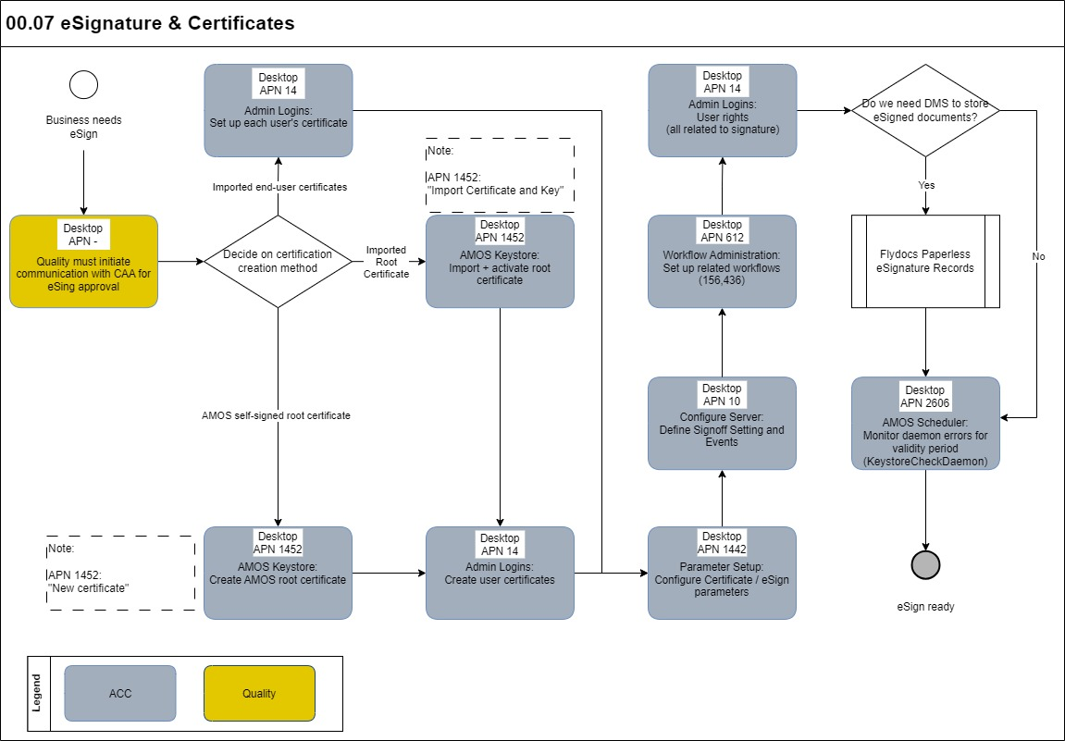

Process Design Questions

# | Question | Answer
1
2
3
4
5
6

Data (Source) Mapping

Data Sources | Description | Volume / Manual / Automatic / Static / Dynamic
-

Other Software Used

Other Software | Used by: | Description
Acrobat Reader | Business users | Electronic signatures can be viewed in a PDF reader

AMOS Configuration

Basic Data

Basic Data Table | Notes
-

Parameters

Parameter Code | Parameter Name | Notes
1463 | CONFIGURE EXTERNAL ELECTRONIC SIGNATURE SERVICE
1492 | E-SIGN TIMESTAMP URL
1493 | E-SIGN TIMESTAMP POLICY
1643 | E-SIGN password complexity
1644 | E-SIGN different password policy

Workflows

Workflow Number | Workflow Name | Notes
477 | Clocked-in Check for Sign-off Event | The workflow is triggered whenever a Clocked-in check for a Sign-off event is performed
156 | Electronic Signature | This workflow can be triggered from Authentication Event action.
179 | Electronic Signature Error Workflow | This workflow is triggered when an error occurs while performing an Electronic Signature.
188 | Electronic Signature Reject Workflow | This workflow is triggered when an e-sign queue entry is rejected.
189 | Electronic Signature Invalidate Workflow | This workflow is triggered when an e-signed document is invalidated in the sign queue history.
436 | AMOSmobile Electronic Signature | This workflow can be triggered from Authentication Event actions in AMOSmobile
470 | Mobile Electronic Signature Reject Workflow | This workflow is triggered when an e-sign queue entry is rejected in AMOSmobile.

Scheduled Tasks

Scheduled Task Reference | Frequency | Notes
KeystoreCheckDaemon | Automatic | Checks certificate expiry automatically

API’s & Interfaces

Reference | Direction | Trigger | Frequency
IMPORT INVALIDATE ESIGN | Import | External  (going back from Flight to Preflight state) | Random

Annex – Additional Info

